RIPPLE PARISH COUNCIL MEETING
Minutes of the Parish Council Meeting held 14 April 2025 at Ripple Parish Hall
Present: Cllrs. M Peters (Chairman), M Davis, P Turner CC M Allen(left at 19:38 ), D Cllr J Owenson (left at 20:04)
Attendees: Clerk/RFO M Hinde and 2 member of the public

Minutes of Ripple Parish Council Meeting
14.04.25.1  14.04.25.2 | To note apologies for absence and to confirm meeting is quorate  Council received apologies from Cllr Ian Davis and the meeting was declared quorate.  To review co-option application and agree actions  After reviewing the co-option application the Council unanimously AGREED to co-opt Susan Petri. As Susan had sent her apologies her acceptance of office will be signed at the next meeting
14.04.25.3 | To receive comments from the public – no decisions will be made on issues raised. Any items requiring decisions will be added to the agenda for the next meeting (NB Councils cannot lawfully decide items of business that are not specified on the agenda (LGA 1972 Sch 12, paras 10 (2)(b) and Longfield Parish Council v Wright (1918) 88 LJ Ch 119)  Resident 1 – Michael Follet sent apologies but asked to mention if the path from Ryall Meadow to Ryall Meadow field. Could the Lengthsman be asked to clear the path?
14.04.25.4 | To receive declarations of interest on the agenda below (Localism Act 2011)  None
14.04.25.5 | To confirm and agree minutes of the Parish Council Meeting held on 24th February 2025  Council APPROVED minutes from 24th February 2025
14.04.25.6 | To receive Clerks Report and agree actions  The clerk advised that the Lengthsman would return to his role on 7th May  The clerk advised that the British Heart Foundation offer grants for defibrillators  Refund VAT of £1484 received  Newsletter – Clerk asked if a newsletter was to be produced to advertise the Annual Parish Meeting and provide a Council update. Cllr Peters advised he would put one together for approval.
14.04.25.7 | To receive County Councillors report and agree actions  County Councillor gave his report as per APPENDIX 1
14.04.25.8 | To receive District Councillors report and agree actions  SWDP Review will get approved this year which will give a breathing space moving forward. SWDP took so long as it was quite dramatic in its plan. Originally designed in supplying 10 years housing supply rather than 5. Published new district plan outlines millions for infrastructure investment such as improve Tunnel Hill area to make it more multi use such as a community hub. Investment in MHDC assets such as Malvern Town Football Club. The 2nd part is investment community bodies such as the Rugby Club in Upton want money towards public toilets and changing rooms. MHDC have a Rural Business Development Fund. Local rural businesses can get match funding to achieve something such as improving shop fronts.  MHDC also provide funding for defibs and blood kits.  Malvern Hills are concentrating on services ensuring they leave it in a good place to be taken over by a Unitary authority.
14.04.25.9 | Finance, all documents circulated prior to the meeting:  - To approve Payment of April 2025 payment list below and those paid since last meeting, to note receipts and agree actions:  Council APPROVED the payment list as per APPENDIX 2 totalling £4078.29  - To approve bank reconciliation up to 31st March 2025  COUNCIL APPROVED bank reconciliation up to 31st March 2025 as per APPENDIX 3  - To approve budget monitoring report up to 31st March 2025  COUNCIL APPROVED budget monitoring report up to 31st March 2025 as per APPENDIX 4  - To agree 2 councillors to complete the Internal Control Document  COUNCIL AGREED that Cllr M Davis and I Davis would complete the Internal Control Document
14.04.25.10 | To discuss applying for Section 106 money from MHDC should there be further development along the A38  Cllr Davis suggested requesting section 106 money to build a community centre along the A38. Cllr Owenson suggested speaking to Mr Surman who has plans to build a club house.  Action: Cllr Turner to speak to Mr Surman about attending the next meeting.
14.04.25.11 | To discuss location of the waste bin to be installed in the Beeches and Ripple  Cllr Peters confirmed that 2 of the 3 parties have agreed location for the bin Ripple and he is just waiting to speak to the 3rd.  A sign has been displayed on the noticeboards in the Beeches and that is currently awaiting approval
14.04.25.12 | To discuss the location of the defibs throughout the parish  Nursing Home require the defib to be moved as the perception Is that the staff are trained in using the defib. Ask Lengthsman if a solid panel could be added to the back of the bus stop for a defib to be mounted. Cllr M Davis to send photos to the clerk along with sketch of what the council would like.
14.04.25.13  14.04.25.14  14.04.25.15 | To consider adopting the phone box in Ripple and agree actions  Phone Box is classed as a listed building. £1 to adopt it. COUNCIL AGREED to adopt the phone box.  To review prices to replace and repair the clerks laptop  Council reviewed 3 quotes and AGREED to replace clerks laptop for £269.00  Planning  Application No: M/25/00433/HP  Location: 1 Grove Cottage, Ryall Grove, Upton Upon Severn, Worcester, WR8 0PP  Description of Proposal: Erection of single and two storey rear extensions, external rendering and replacement windows  Council confirmed NO OBJECTION to this application
14.04.25.15 | To receive items for the next agenda  Annual Meeting
14.04.25.16 | To Agree date of the next meeting

Meeting Close: 20:15

APPENDIX 1
COUNTY COUNCILLOR MARTIN ALLEN
REPORT TO RIPPLE PARISH COUNCIL REPORT APRIL 2025
Good evening.
COUNTY COUNCIL MATTERS
RYALL EAST QUARY APPLICATION & RIPPLE SCHOOL LANE QUARY FOR MINERALS APPLICATION (CEMEX)
No more news that I gave you below in February except to say the re-consultation ended on the 24th of March.
GULLY PROBLEMS IN NAUNTON DRAINAGE WORK/FLOOD ALLEVIATION #8644
As you know, work is to be undertaken commencing on 04/08/25 until 08/08/25 0800-1500 each day to carryout repairs near to the notice board and Defib. I sent you the map and details on 03.03.25
RYALL GROVE FOOTWAY
This has now been approved for refurbishment, and I am still waiting for a start date, but I have been told it will be done this summer.
ADOPTION OF FURROW CLOSE
I have been chasing this up with Highways, and I forwarded you their email on 24.03.24.
The County Council is currently waiting for Taylor Wimpey to complete remedial works to enable the final certificate of completion to be issued. The County Council will then carry out a further inspection of the works and, subject to the satisfactory rectification of any highlighted defects, issue the final certificate and formally adopt the roads as highways maintainable at public expense.

The timescale for eventual adoption of the roads, however, is dependent upon Taylor Wimpey making a commitment to fulfil their obligations under the terms of the section 38 agreement.

DISTRICT COUNCIL MATTERS
70 HOMES AT THE MARINA/HOLLY GREEN
Still no more news on 70 Homes on the A4104 at Holly Green – This has again gone out to consultation; this site is in the SWDP allocation and has received planning permission in the past. This application is outlaying only, and it will not determine the type and exact location of any properties.
LAND AT HOLLY GREEN FOR 27 HOMES AND 1 X SHOP march
Despite Cllr Owenson’s and mine best efforts, the Southern Area Planning Committee votes in a spit vote to approve the application.
SWDP-R UPDATE
As you know the hearing commenced on Tuesday the 4th of March 2025; it is only programmed in for 4 weeks. I believe it has just started its last week.
Once that hearing is completed, the SWDPR will gain considerable weight.
UNITARY AUTHORITY’S
No more news, we now know that Worcestershire’s district and county councils are in the second wave to become a Unitary Authority.
A progress report must be in place by the end of March this year. A full plan is to be in place in November this year.
The Shadow Authority will be formed in 2027, currently both WCC and MHDC will run until April 2028.
MHDC voted to explore both a Worcestershire Unitary Authority and a South Worcestershire Unitary Authority.

MHDC currently favour the SWUA option, which I also voted in favour of.
Worcester City, Wychavon and MHDC residents total approximately 320 thousand.
North Worcestershire total 280 thousand.
It is not known at the moment if the government will accept this option.
Warmest Regards
Cllr Martin Allen

APPENDIX 2
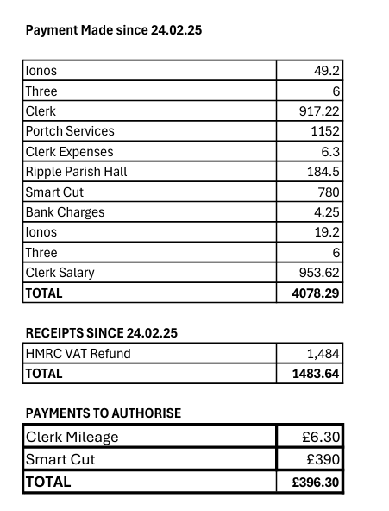

APPENDIX 3
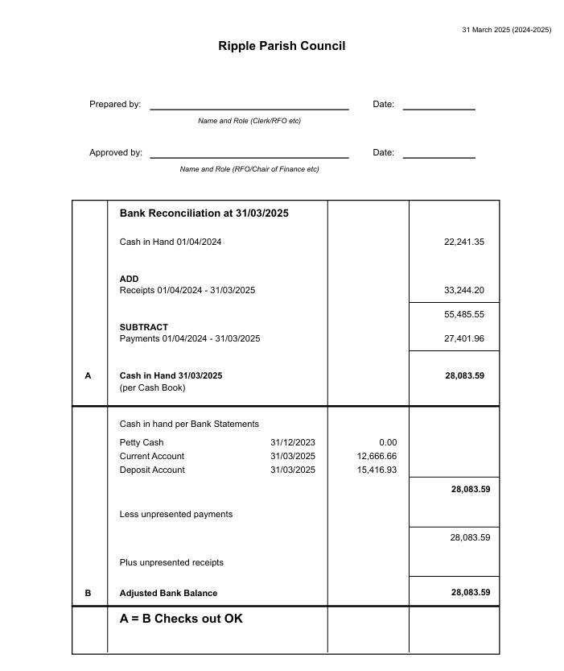

APPENDIX 4
